**The Element Sign in is clicked**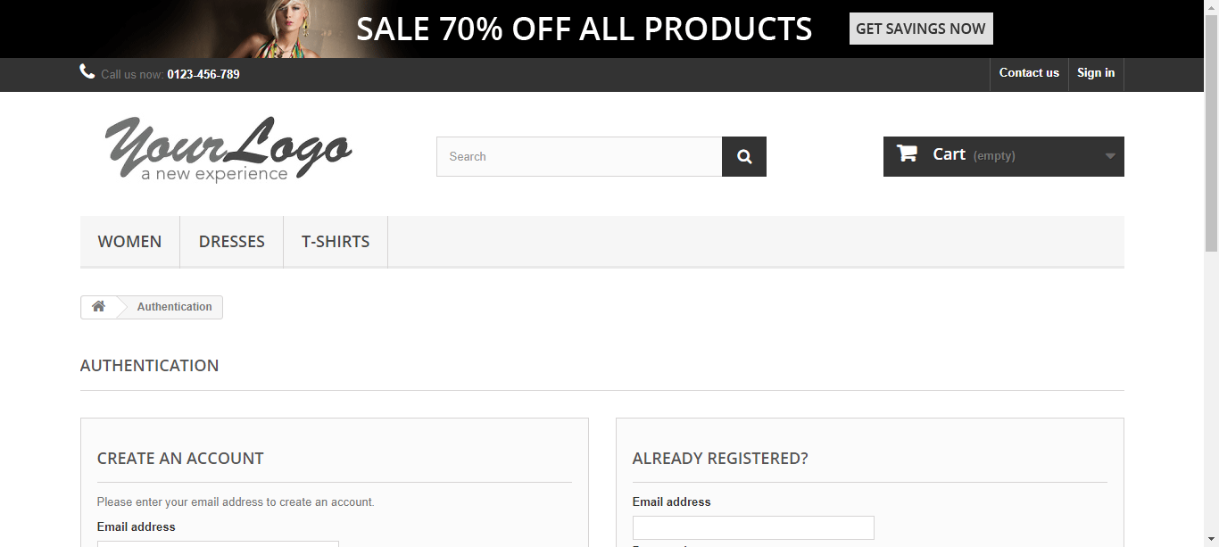

**The input Automation@americantech.com has been entered sucessfully**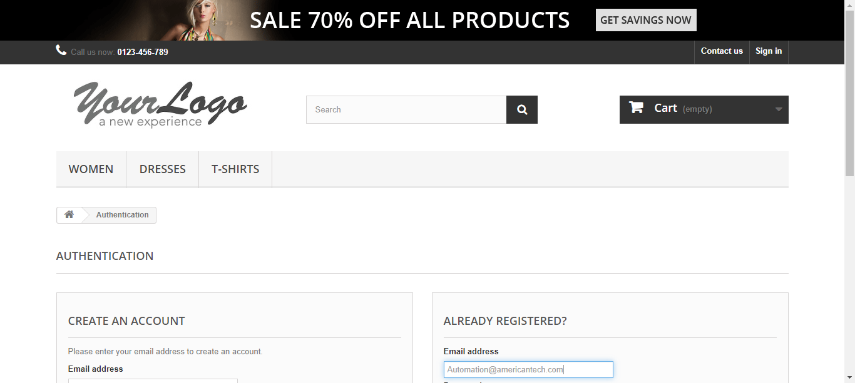

**The input Jan@2020 has been entered sucessfully**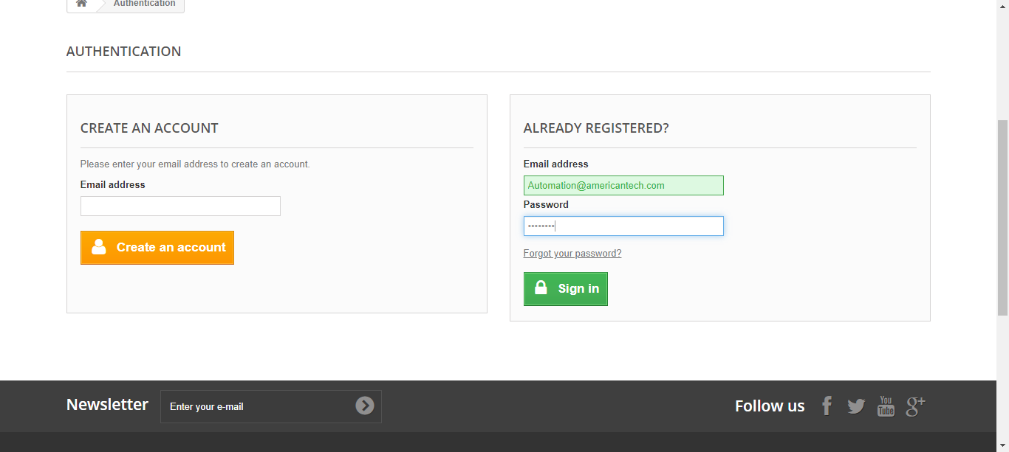

**The Element Sign in is clicked**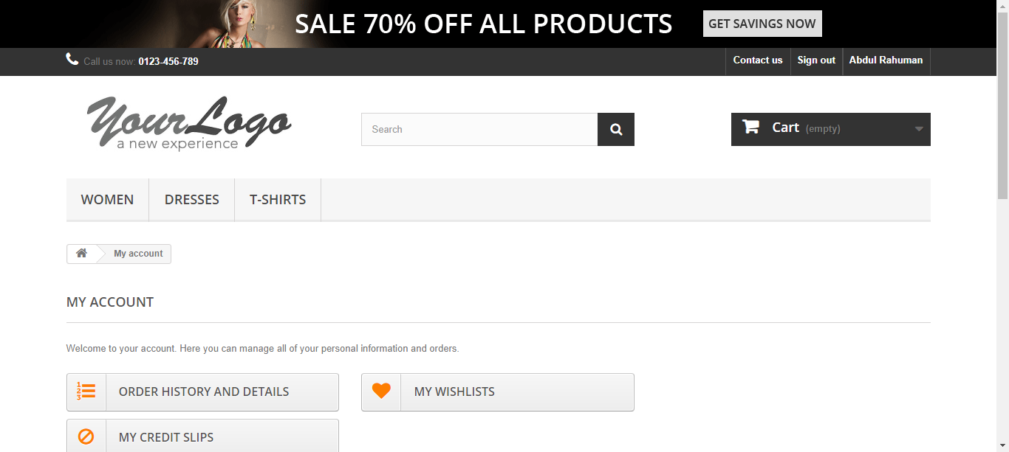

**The Element MY ADDRESSES is clicked**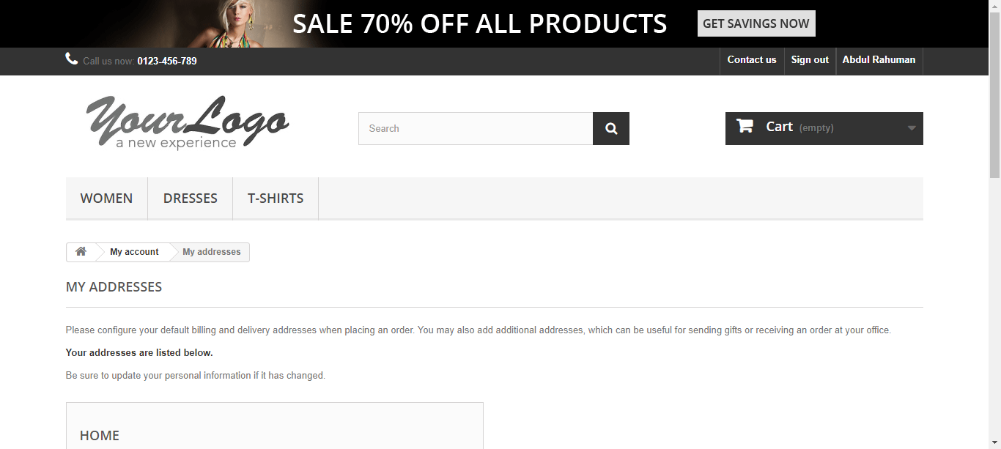

**The Element Add a new address is clicked**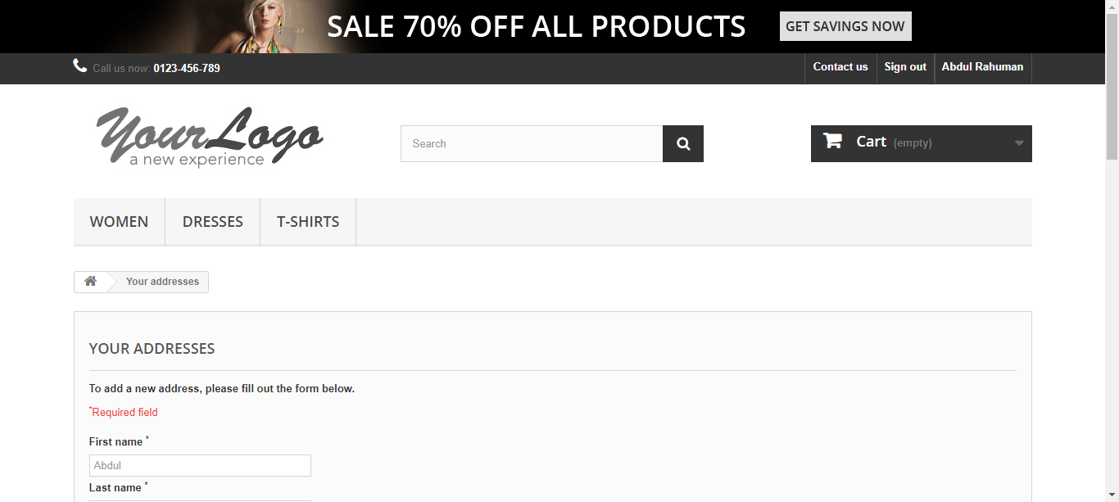

**The input Virat has been entered sucessfully**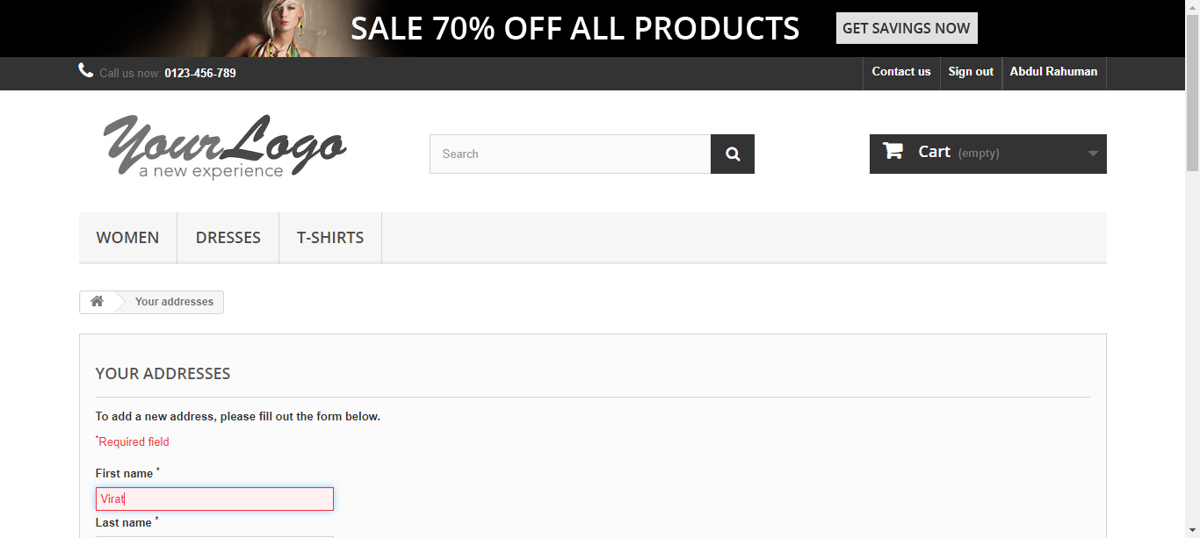

**The input Kohli has been entered sucessfully**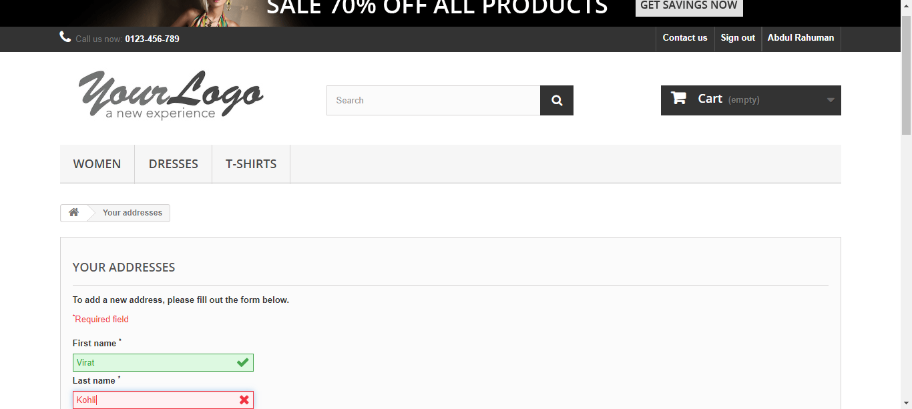

**The input Viratkohli foundation has been entered sucessfully**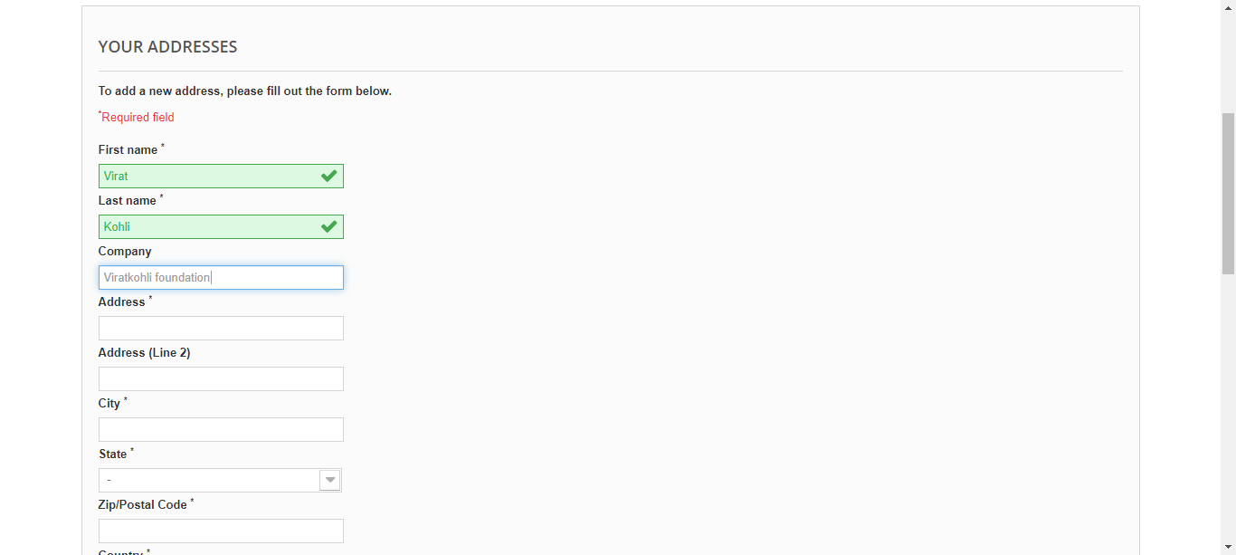

**The input Delhi has been entered sucessfully**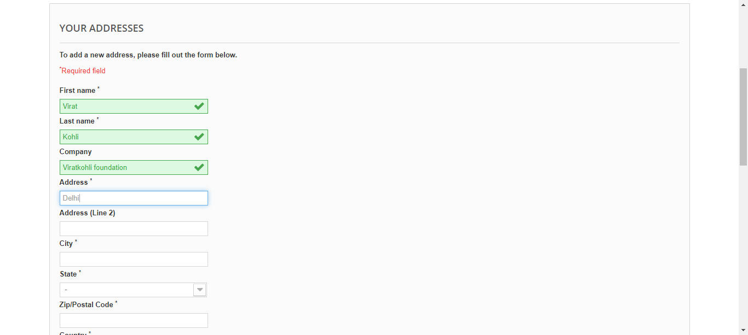

**The input Feroz shah kotla has been entered sucessfully**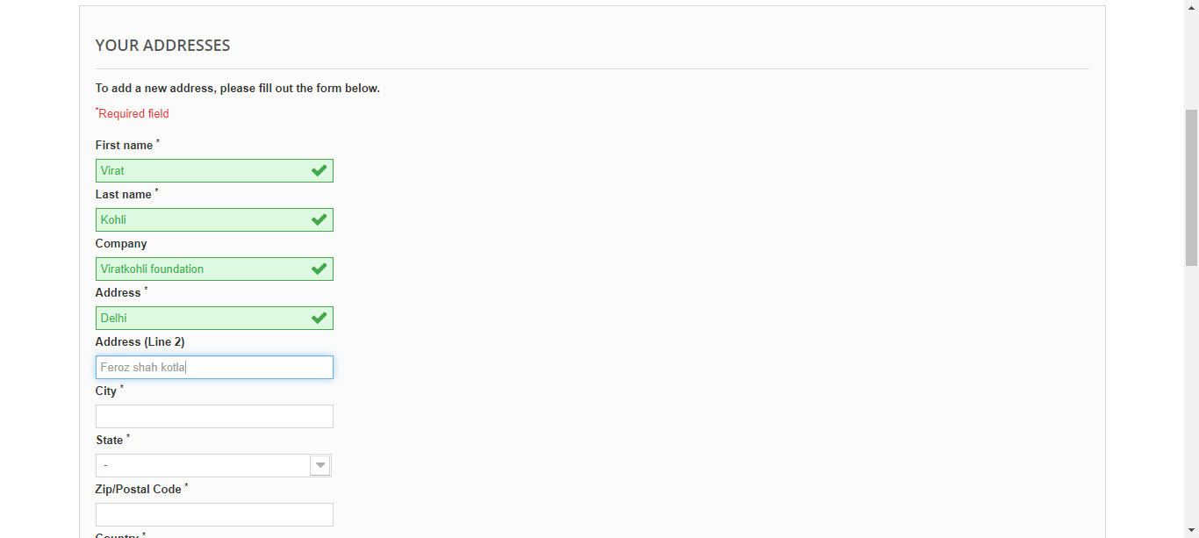

**The input Delhi has been entered sucessfully**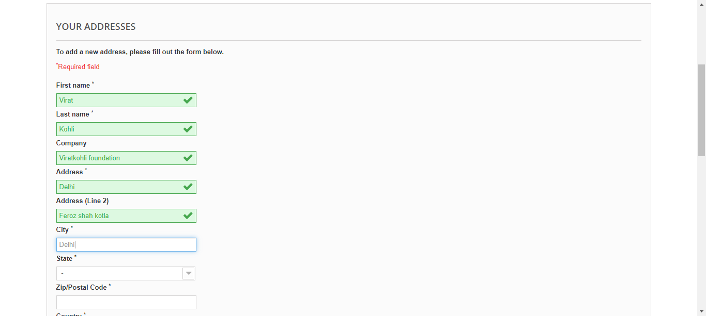

**The input 60028 has been entered sucessfully**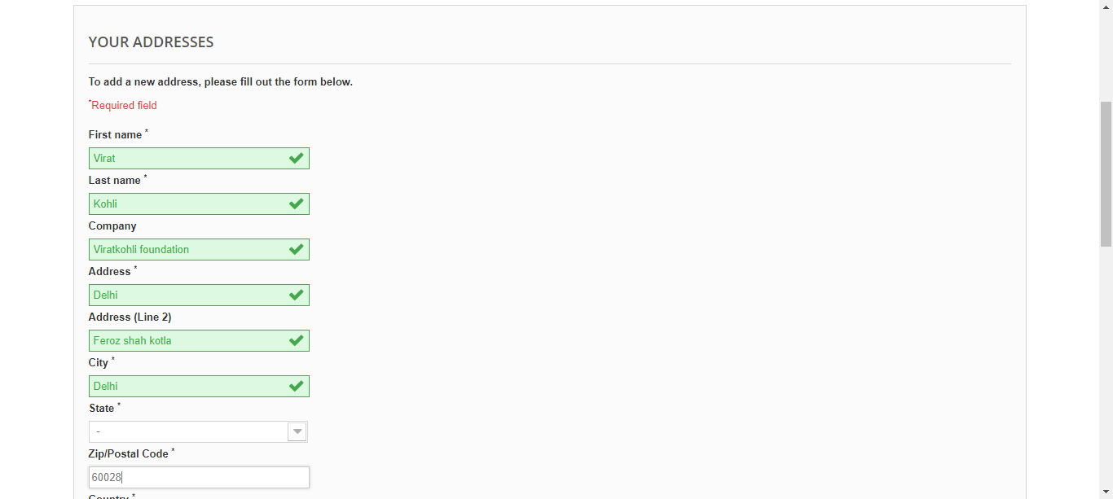

**The input 88102030 has been entered sucessfully**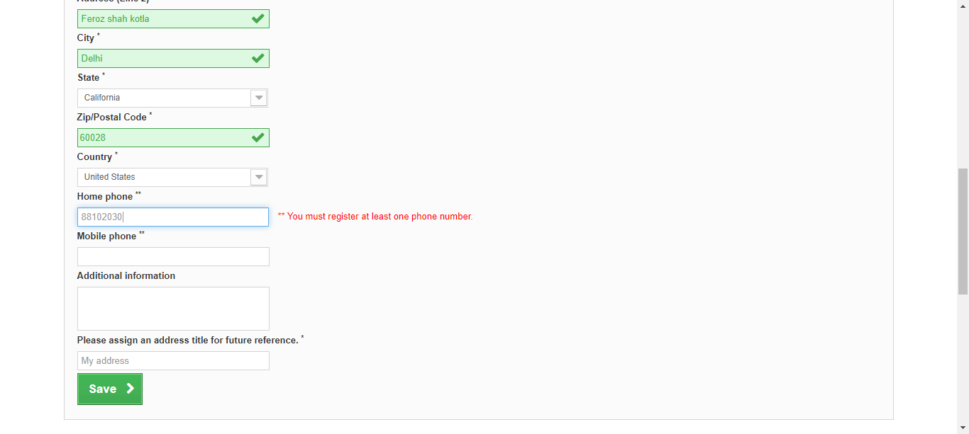

**The input 8879501 has been entered sucessfully**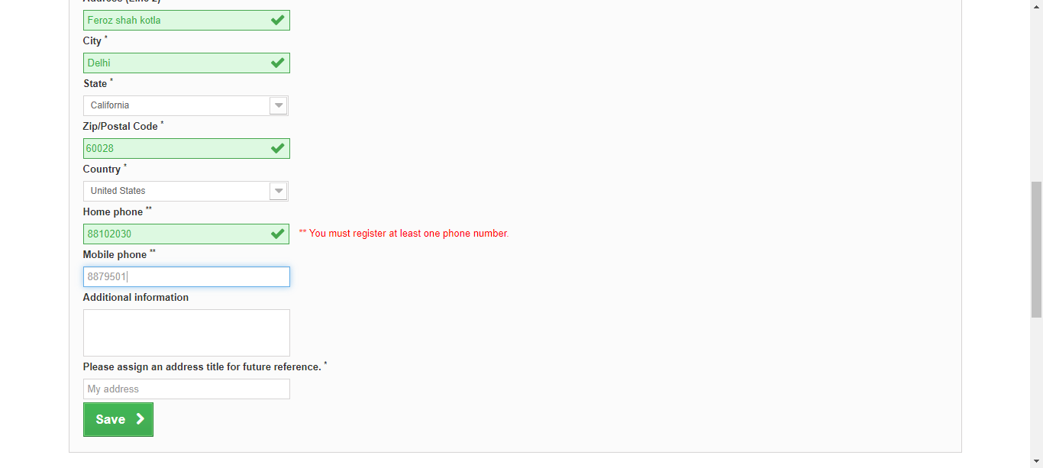

**The input info has been entered sucessfully**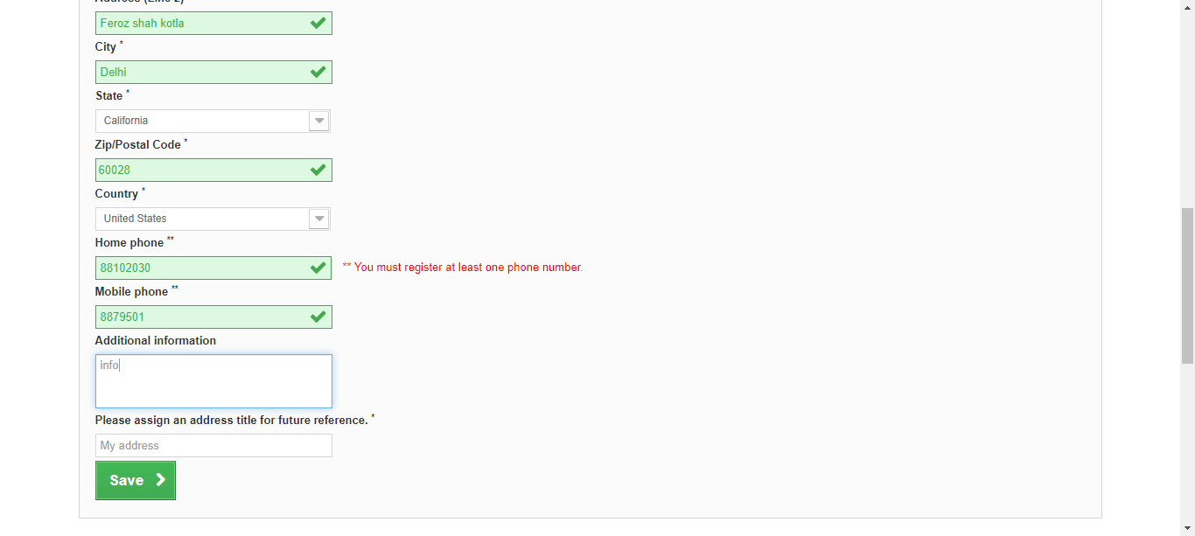

**The input aliasName3 has been entered sucessfully**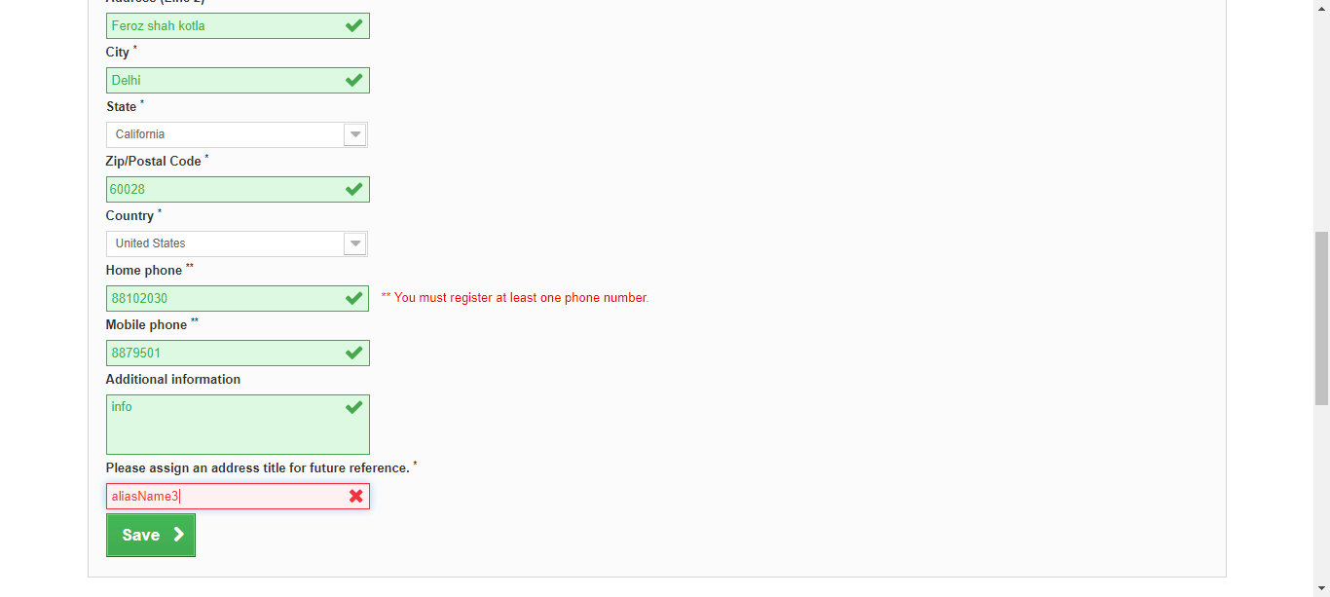

**The Element Save is clicked**